Contents

**Introduction:** 1

**Testing list:** 1

**Test Plan:** 1

**Test Design:** 3

**Unit testing:** 3

**Integration Testing:** 4

**Functional Testing:** 5

**Usability Testing:** 8

**Security Testing:** 9

**Browser Compability Testing:** 11

**Test Log:** 13

**Introduction:**

We have built a website same as Harvard university website. For creating this website appropriately, we discuss all of the functionality, use case and testing then we made a plan as team. Then we make this website by using content management system (CMS). We use share point to create this website.

# **Testing list:**

1. Unit testing
2. Integration testing
3. Function testing
4. Usability testing
5. Security testing
6. Browsing compability testing

**Test Plan:** A testing plan has been made from the starting of this system. In that test plant name of that testing, testing criteria and what will be the outcome are described.

|  |  |  |  |
| --- | --- | --- | --- |
| **Test No** | **Name** | **Criteria** | **Outcome** |
| 1 | Unit test | Add news  Comment | All of these test result will be appropriate. |
| 2 | Integration test | Email sends  View course | All these functional tests will be appropriate. |
| 3 | Functional test | Add event | This function will work appropriately by maintain its sequence and will provide expected result. |
| 4 | Usability test | Search field  Navigation bar  Page details | These functions for all the items will be accurate. |
| 5 | Security test | User authentication  SQL injection  Bruit Force attack | Expected result of security testing will be appropriate. |
| 6 | Browser compability test | Microsoft edge  Mozilla Firefox  Google Chrome | System will work and visible same in every browser. |

# **Test Design:**

## **Unit testing:**

|  |  |  |  |  |  |
| --- | --- | --- | --- | --- | --- |
| **Testing no** | **Title** | **Pre-condition** | **Test Steps** | **Expected Result** | **Actual Result** |
| 1 | Updating event time | Have to change event time | Update new event time | Expected result has been found. | Expected result |

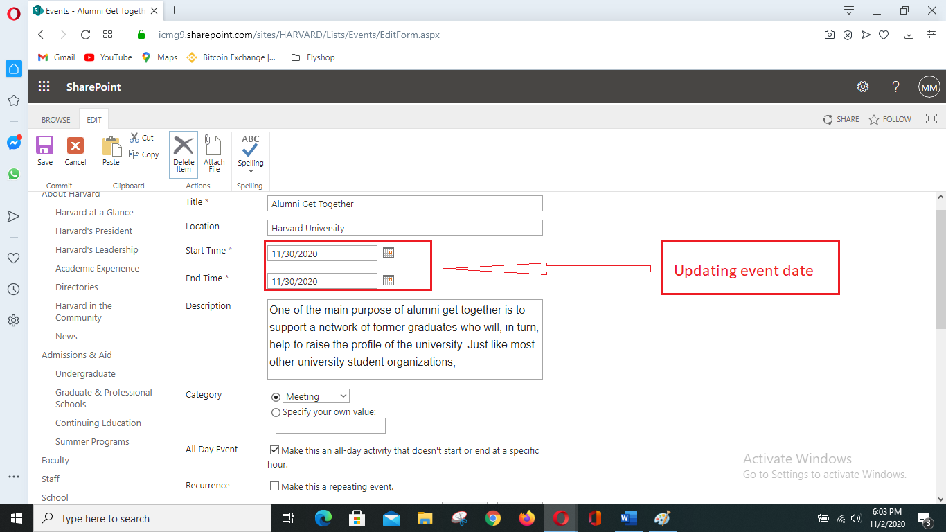

Figure 1: Updating event date

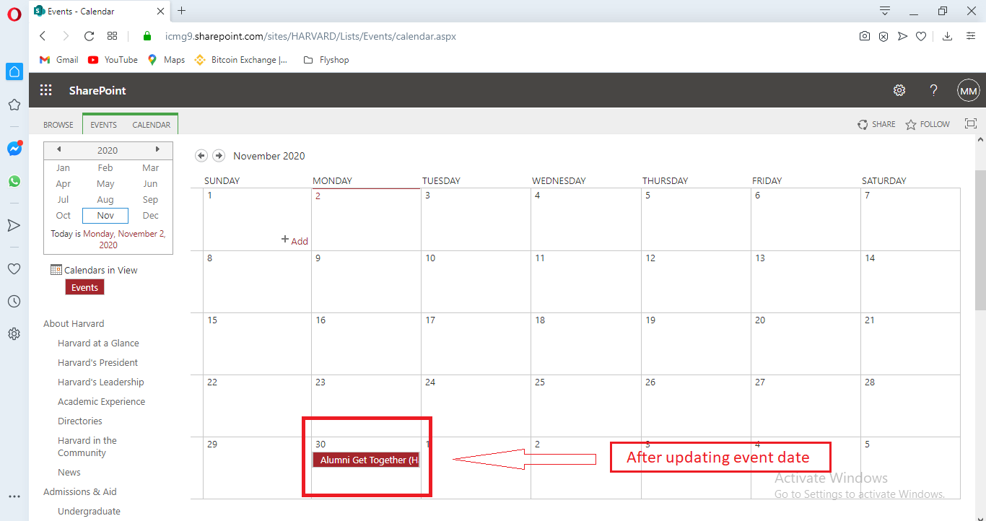

Figure 2: Calendar after updating event date

## **Integration Testing:**

|  |  |  |  |  |  |
| --- | --- | --- | --- | --- | --- |
| **Testing no** | **Title** | **Pre-condition** | **Test Steps** | **Expected Result** | **Actual Result** |
| 2 | Reply to a comment | Commenting | Reply | Result was expected | Expected result |

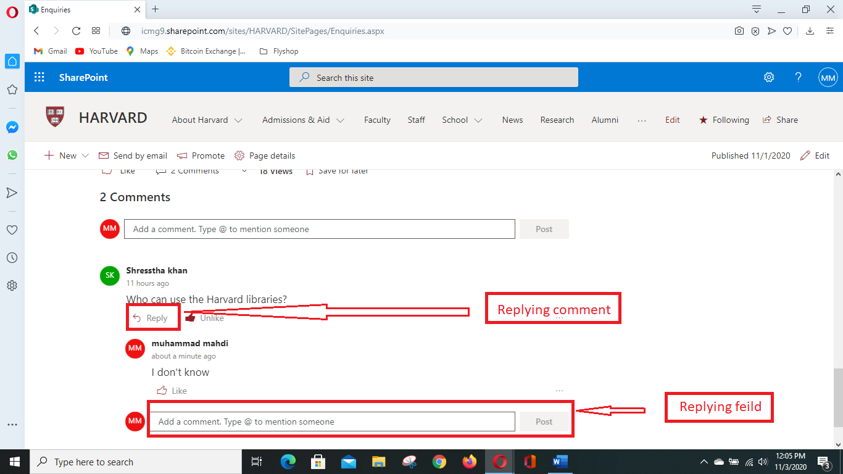

Figure 3: Replying a comment

## **Functional Testing:**

|  |  |  |  |  |  |
| --- | --- | --- | --- | --- | --- |
| **Testing no** | **Title** | **Pre-condition** | **Test Steps** | **Expected Result** | **Actual Result** |
| 3 | Event creating | Process of event creating | Event create | Result was expected | Result as expected. |

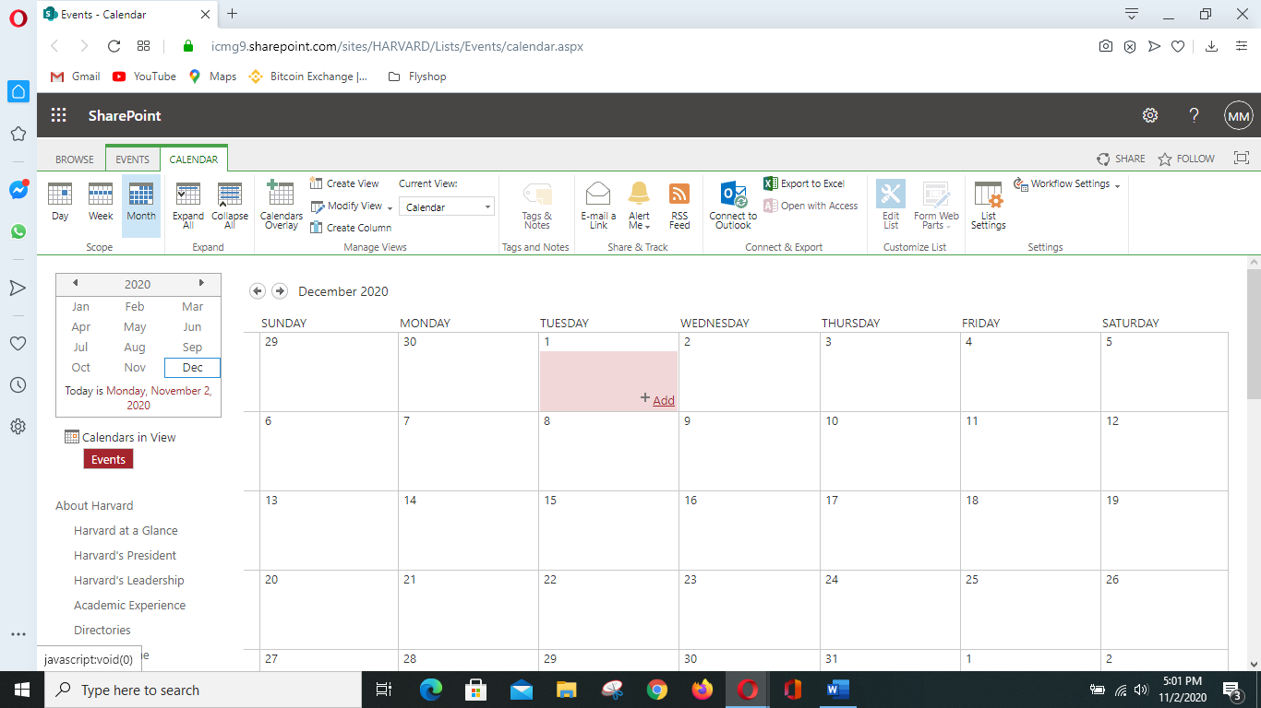

Figure 4: Creating event

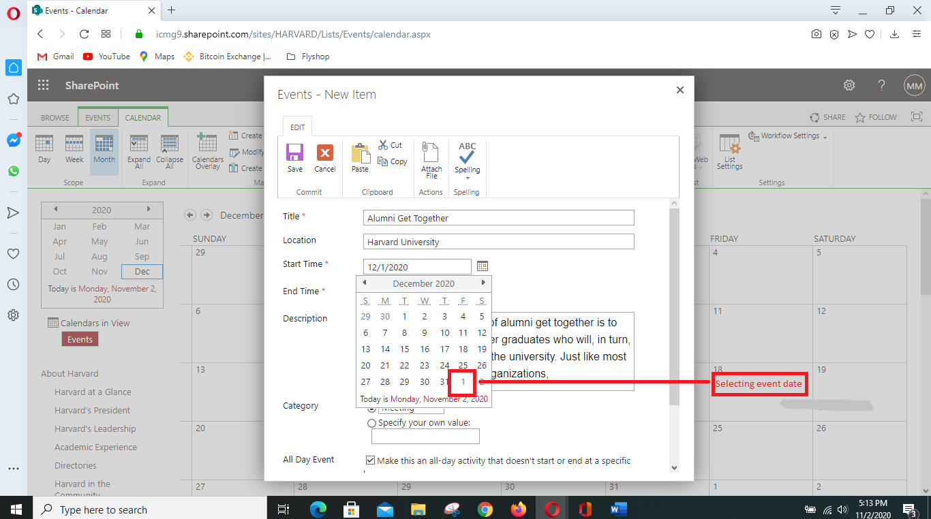

Figure 5: Selecting event date from the calendar

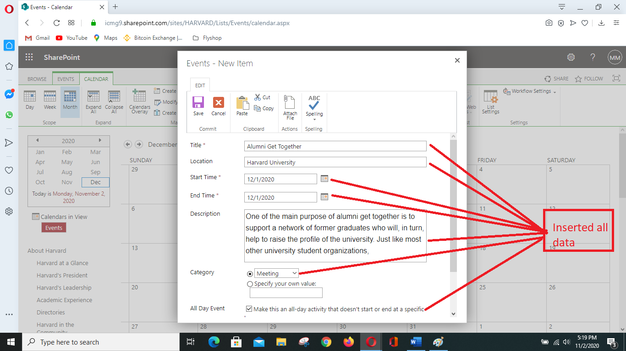

Figure 6: Fill-up all fields for creating event

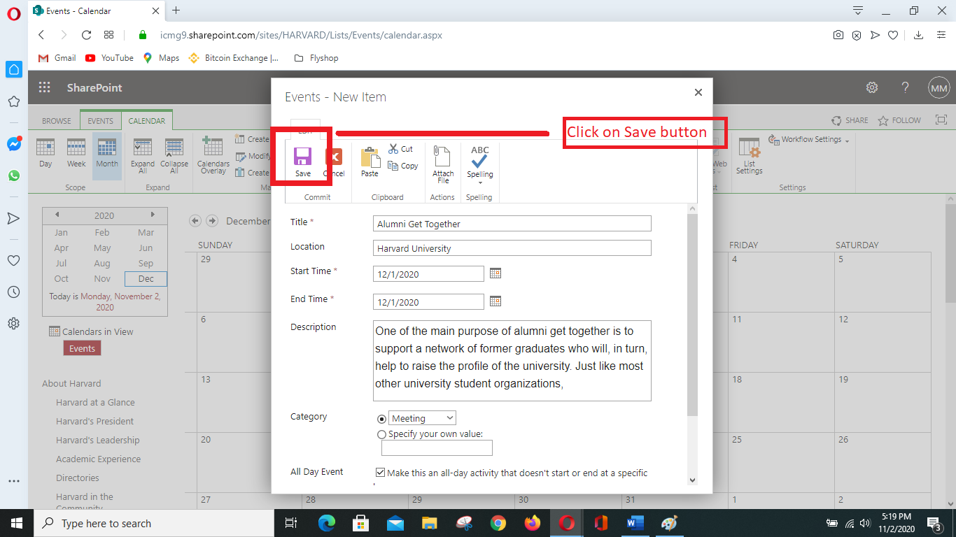

Figure 7: Save option for saving event details.

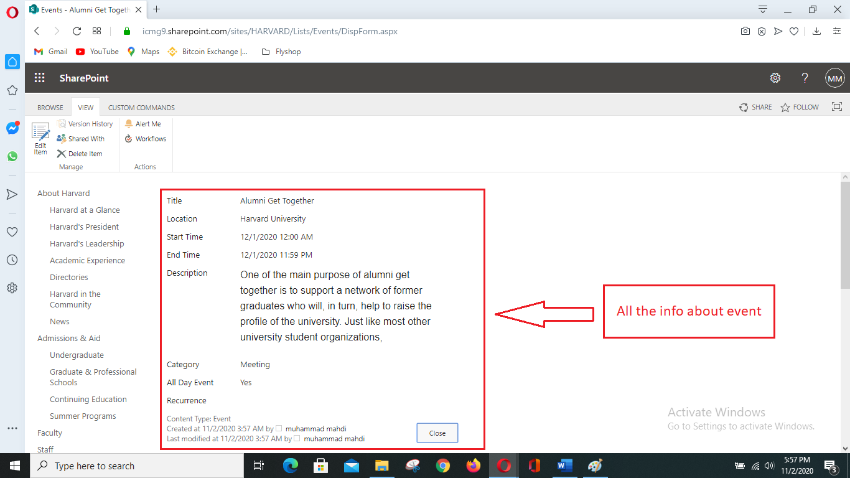

Figure 8: Overview after creating event.

## **Usability Testing:**

|  |  |  |  |  |  |
| --- | --- | --- | --- | --- | --- |
| **Testing no** | **Title** | **Pre-condition** | **Test Steps** | **Expected Result** | **Actual Result** |
| 4 | Search bar & user-friendly navigation bar | Navigation bar user friendly | Color and size are friendly for user. | Results were same. | Expected |

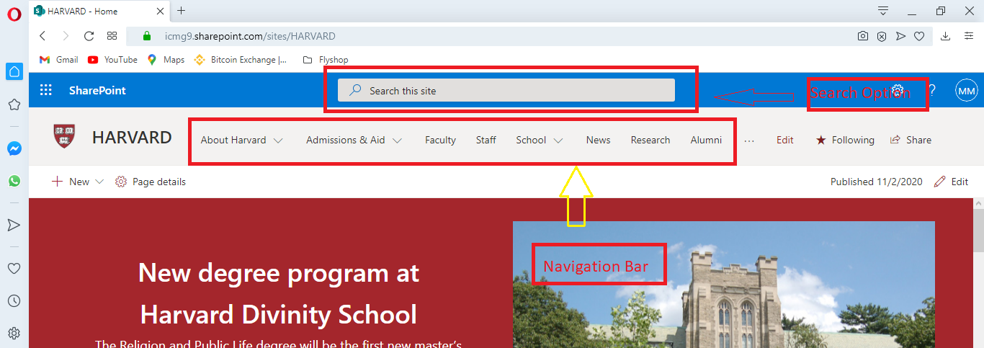

Figure 9: User-friendly navigation bar and search option.

## **Security Testing:**

|  |  |  |  |  |  |
| --- | --- | --- | --- | --- | --- |
| **Testing no** | **Title** | **Pre-condition** | **Test Steps** | **Expected Result** | **Actual Result** |
| 5 | Processing of authentication | Email signup | Complete task | Expected result has been found | Expected result. |

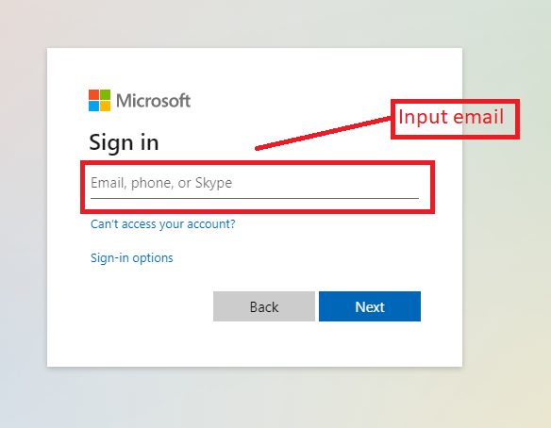

Figure 10: User authentication process

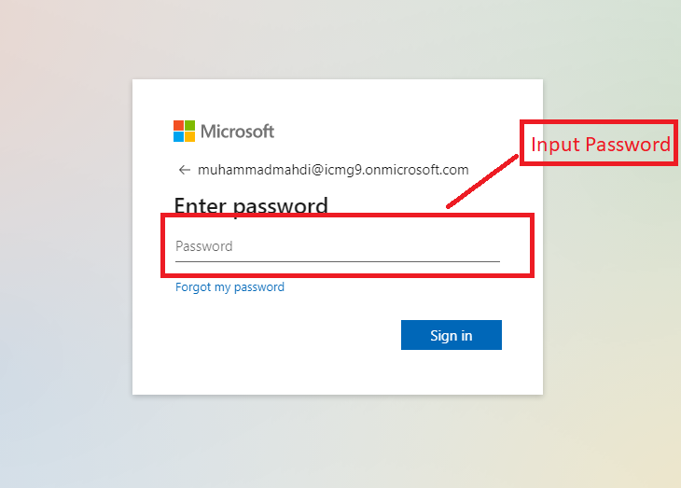

Figure 11: User authentication process.

## **Browser Compability Testing:**

|  |  |  |  |  |  |
| --- | --- | --- | --- | --- | --- |
| **Testing no** | **Title** | **Pre-condition** | **Test Steps** | **Expected Result** | **Actual Result** |
| 6 | Testing feature from different browser | Availability check | System will run in few different browsers. | Results were same. | Expected. |

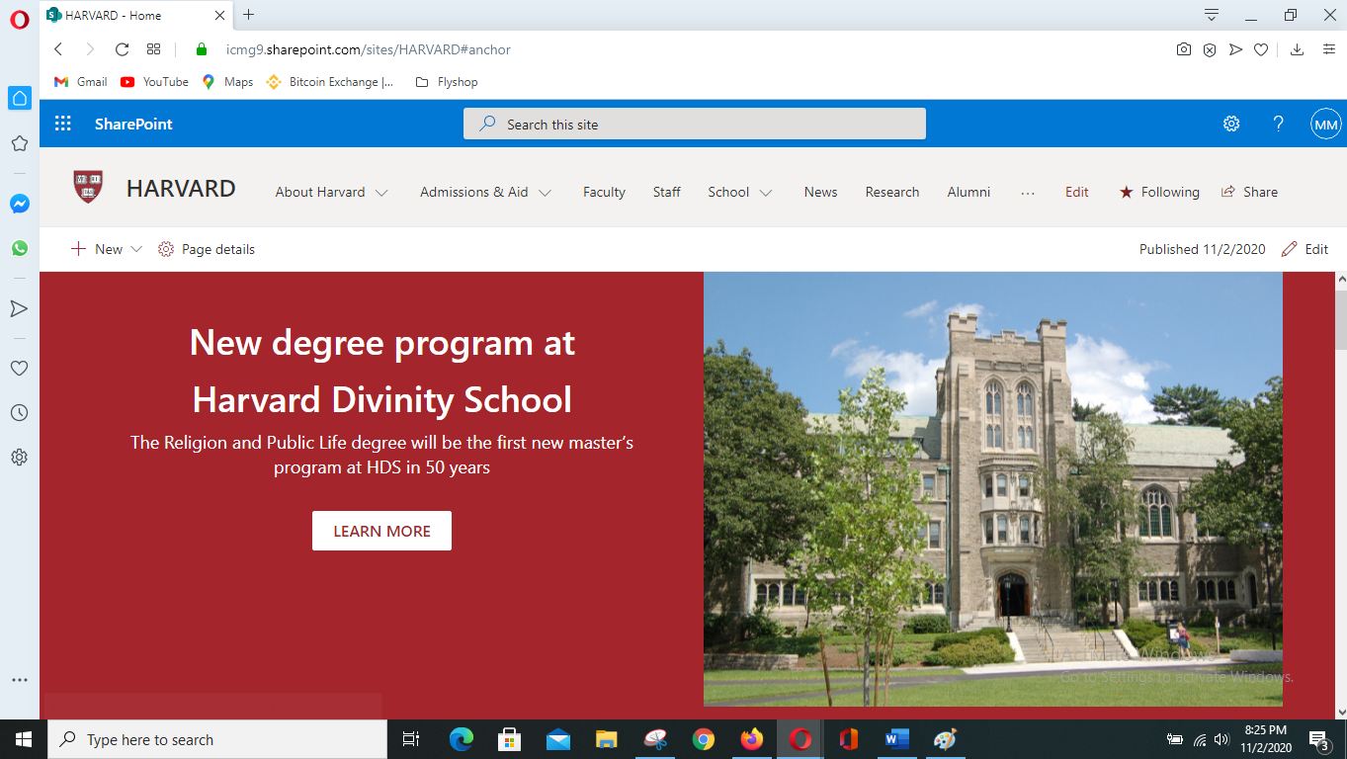

Figure 12: System testing in opera browser.

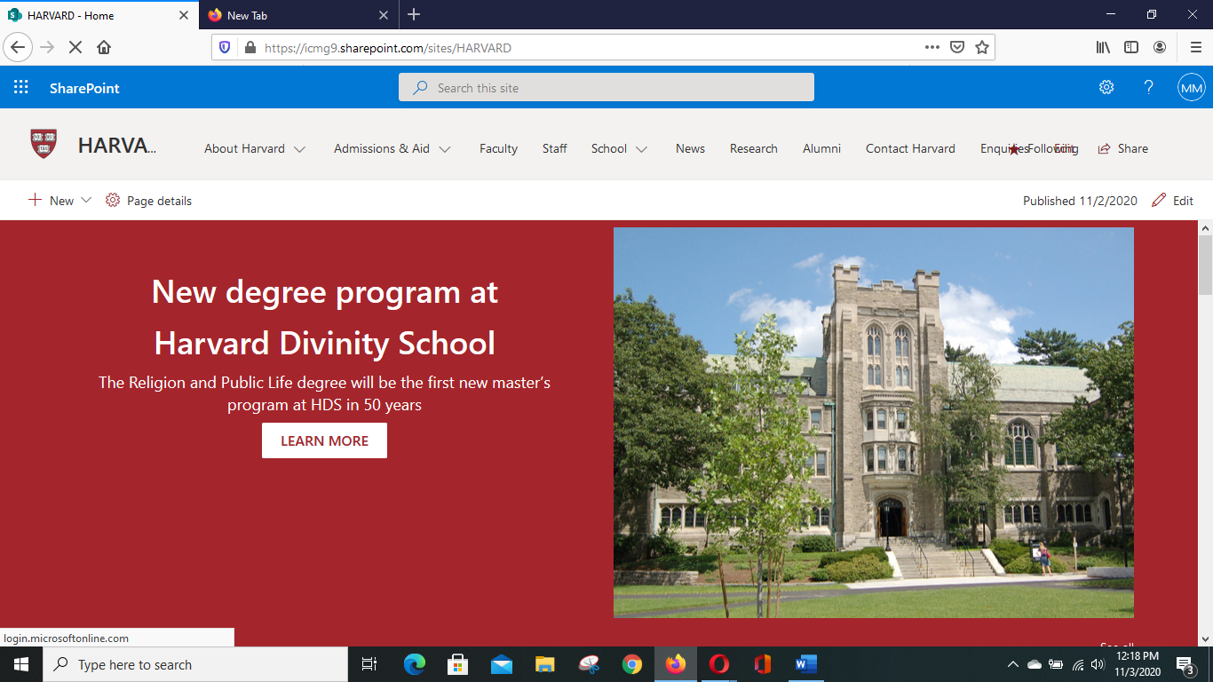

Figure 13: System testing in Mozilla Firefox browser.

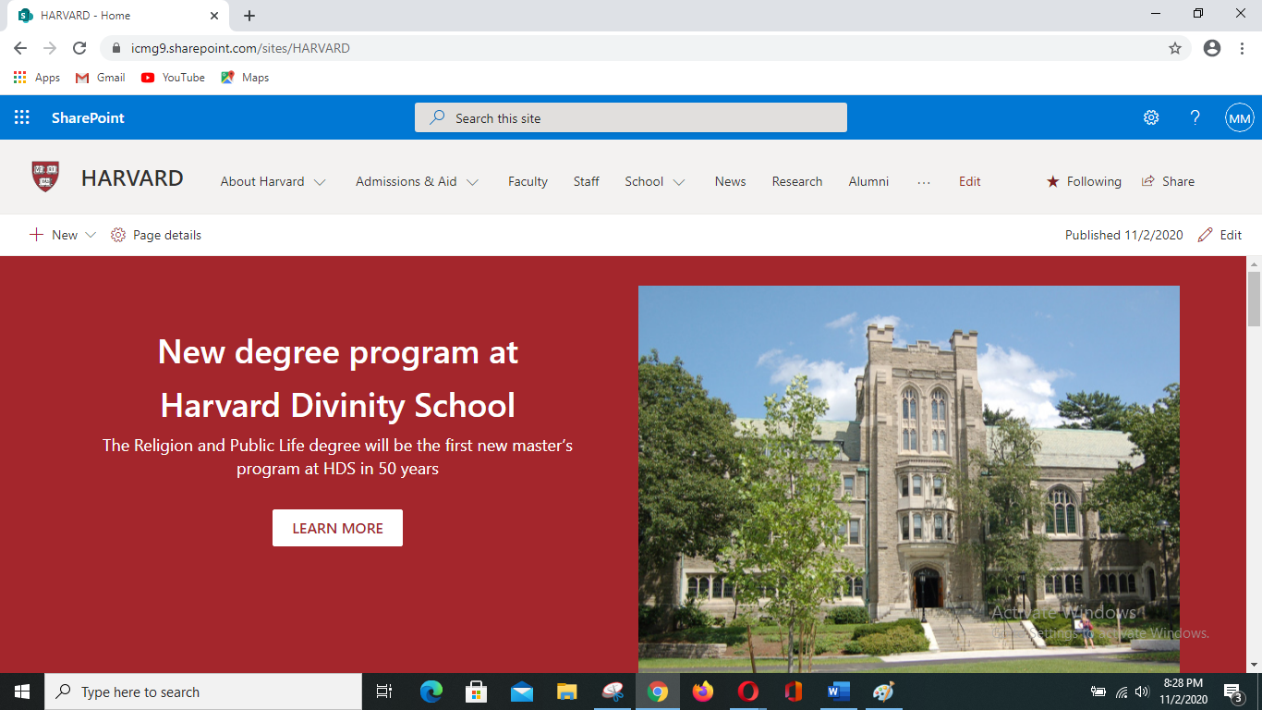

Figure 14: System testing in Google chrome browser.

# **Test Log:**

|  |  |  |  |  |  |  |  |
| --- | --- | --- | --- | --- | --- | --- | --- |
| Testing no | Title | Pre-condition | Test steps | Expected result | Actual result | Action | Date |
| 1 | Updating event time. | Have to change event time | Update new event time | Expected result has been found. | Expected result | Update | 03-11-2020 |
| 2 | Reply to a comment | Commenting | Reply | Result was expected | Expected result | Reply | 03-11-2020 |
| 3 | Event creating | Process of event creating | Event create | Result was expected | Result as expected. | Create | 03-11-2020 |
| 4 | Search bar & user-friendly navigation bar | Navigation bar user friendly | Color and size are friendly for user. | Results were same. | Expected | Search | 03-11-2020 |
| 5 | Processing of authentication | Email signup | Complete task | Expected result has been found | Expected result. | Authentication | 03-11-2020 |
| 6 | Testing feature from different browser | Availability check | System will run in few different browsers. | Results were same. | Expected. | Various browser | 03-11-2020 |